XX. PizzaParty

Program Name: PizzaParty
Nick is throwing a pizza party, but he is too cheap to get multiple pizzas so he wants to know how to slice the pizza so that everyone at the party can get one slice of pizza.
Input
The number of slices of pizza
Output
Draw a circle divided into n, number of slices.
Example Input File
3 10
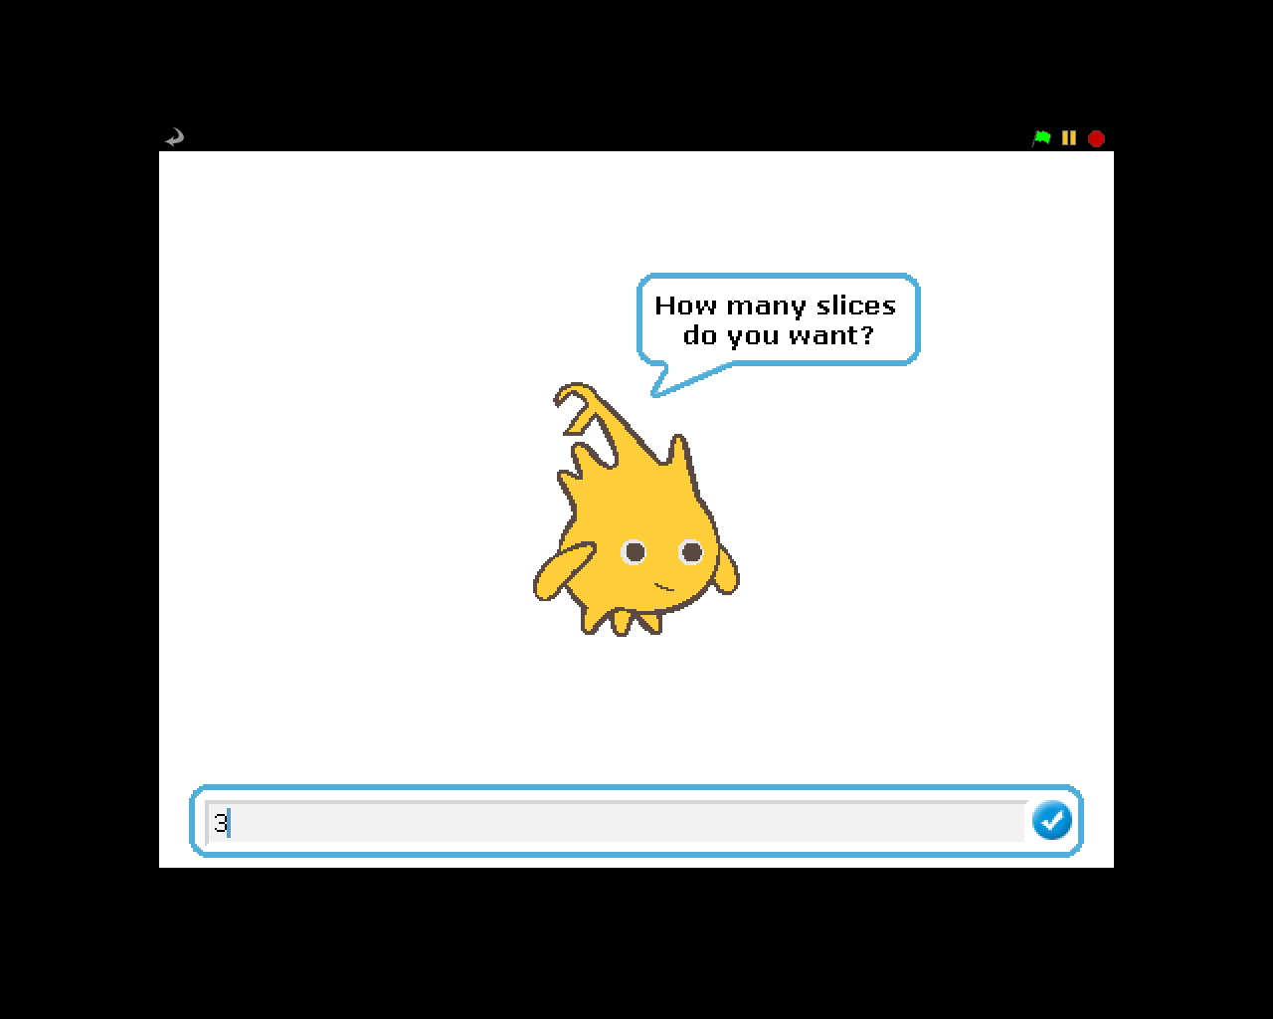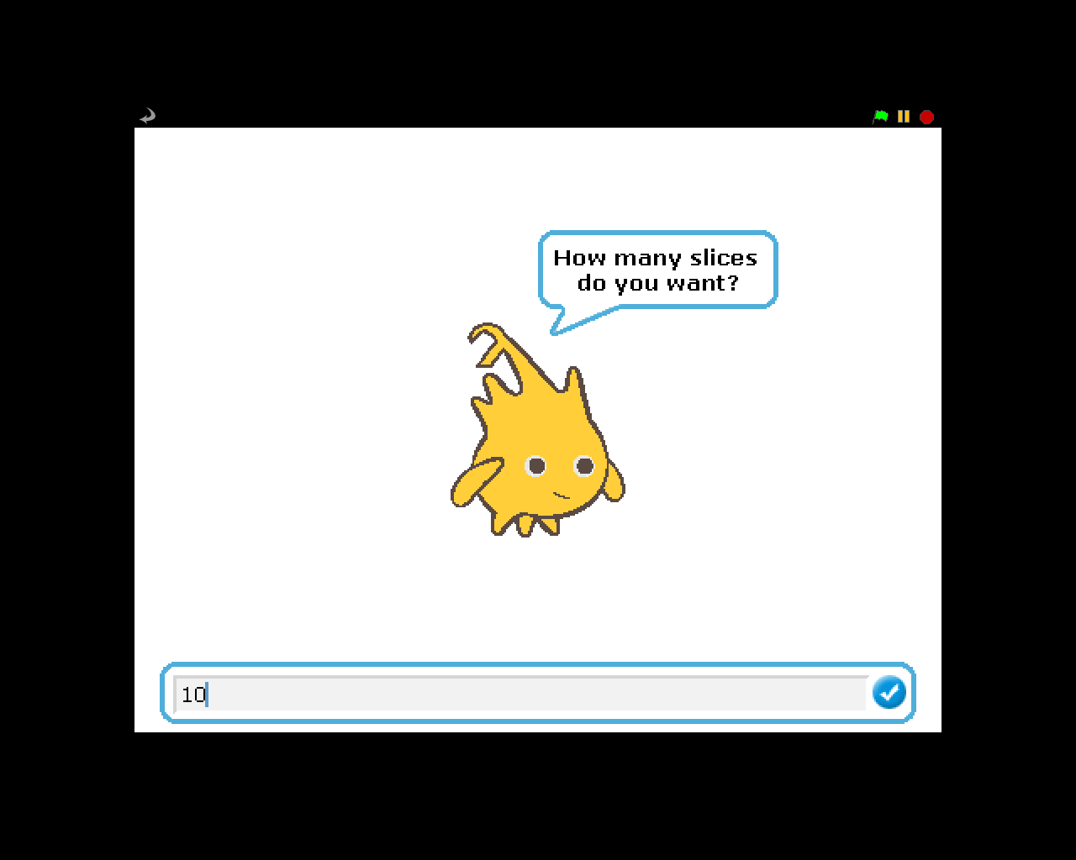
Example Output to Screen
